**Experiment 2:-**Use of appropriate command to determine your

shell, available shells, using ‘who’ command and redirect the to

any text file, ‘more’ to view content in files.

**(a) Use of appropriate command to determine your logic**

**shell.**

➔To find your current shell type following command

-$ echo $SHELL

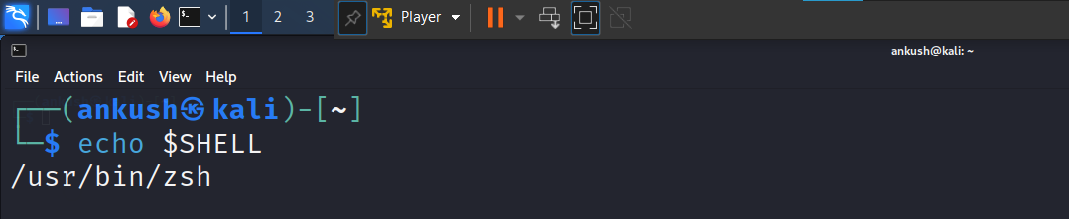

**(b) To find all available shells in your system type which**

**command.**

To find all available shells type command:

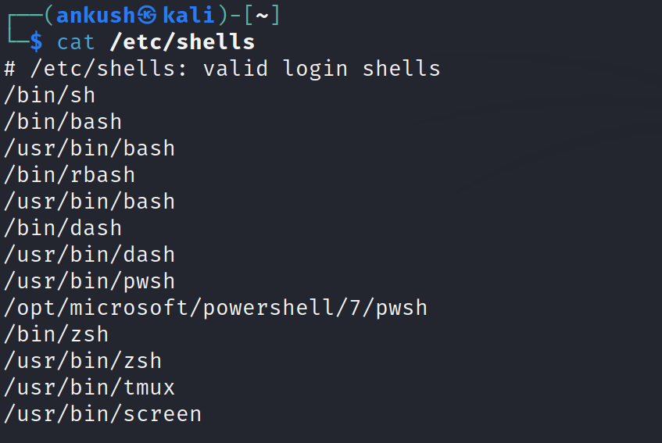

**(c) Which command is use to verify the result of part (b).**

➔To verify the result of step(b) use the following command:

-$ cat /etc/passwd

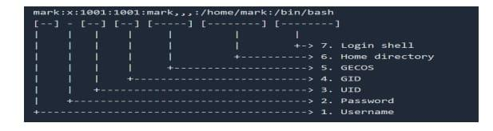

**(d)**

**Use the “who” command and redirect the result to a file called myfile1. Use the more command to see the contents of myfile1.**

➔ Command typed is: - $ who > myfile1.txt

$ more myfile1.txt

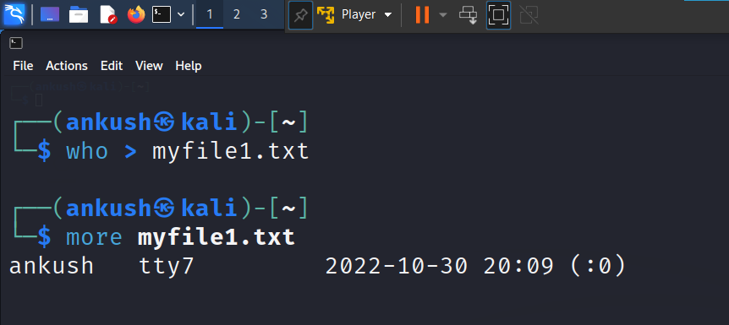

**(a) Use the date and who commands in sequence(in one line) such that the output date will display on the screen and the output of who will be redirected to a file called myfile2. Use the more command to check the contents of myfile2.**

➔ Command typed is:-$ date; who > myfile2.txt

-$ more myfile2.txt.

